1. Run main.py and the first screen should pop up asking whether you want to update the data or run the data visualization. If you update the data, it will take a minute

and then once it is complete you will be able to run the visualization with the updated data. Should look like:

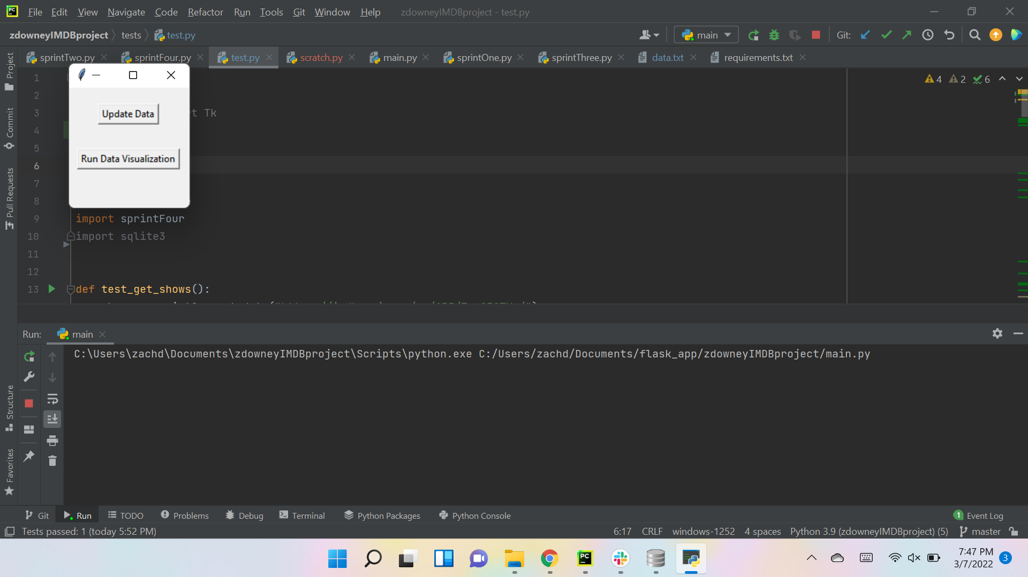  
2. When you run visualization, it should give you seven different options of what visual you want to view:

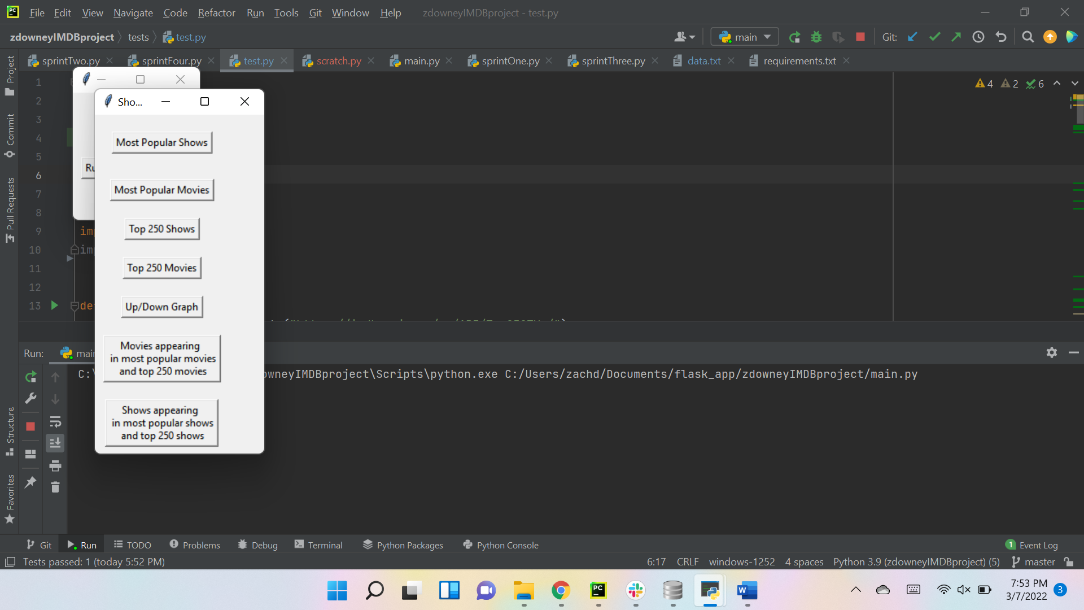

3. When you click on ‘Most Popular Shows’, you should get a large with a scroll bar listing the 100 most popular shows:

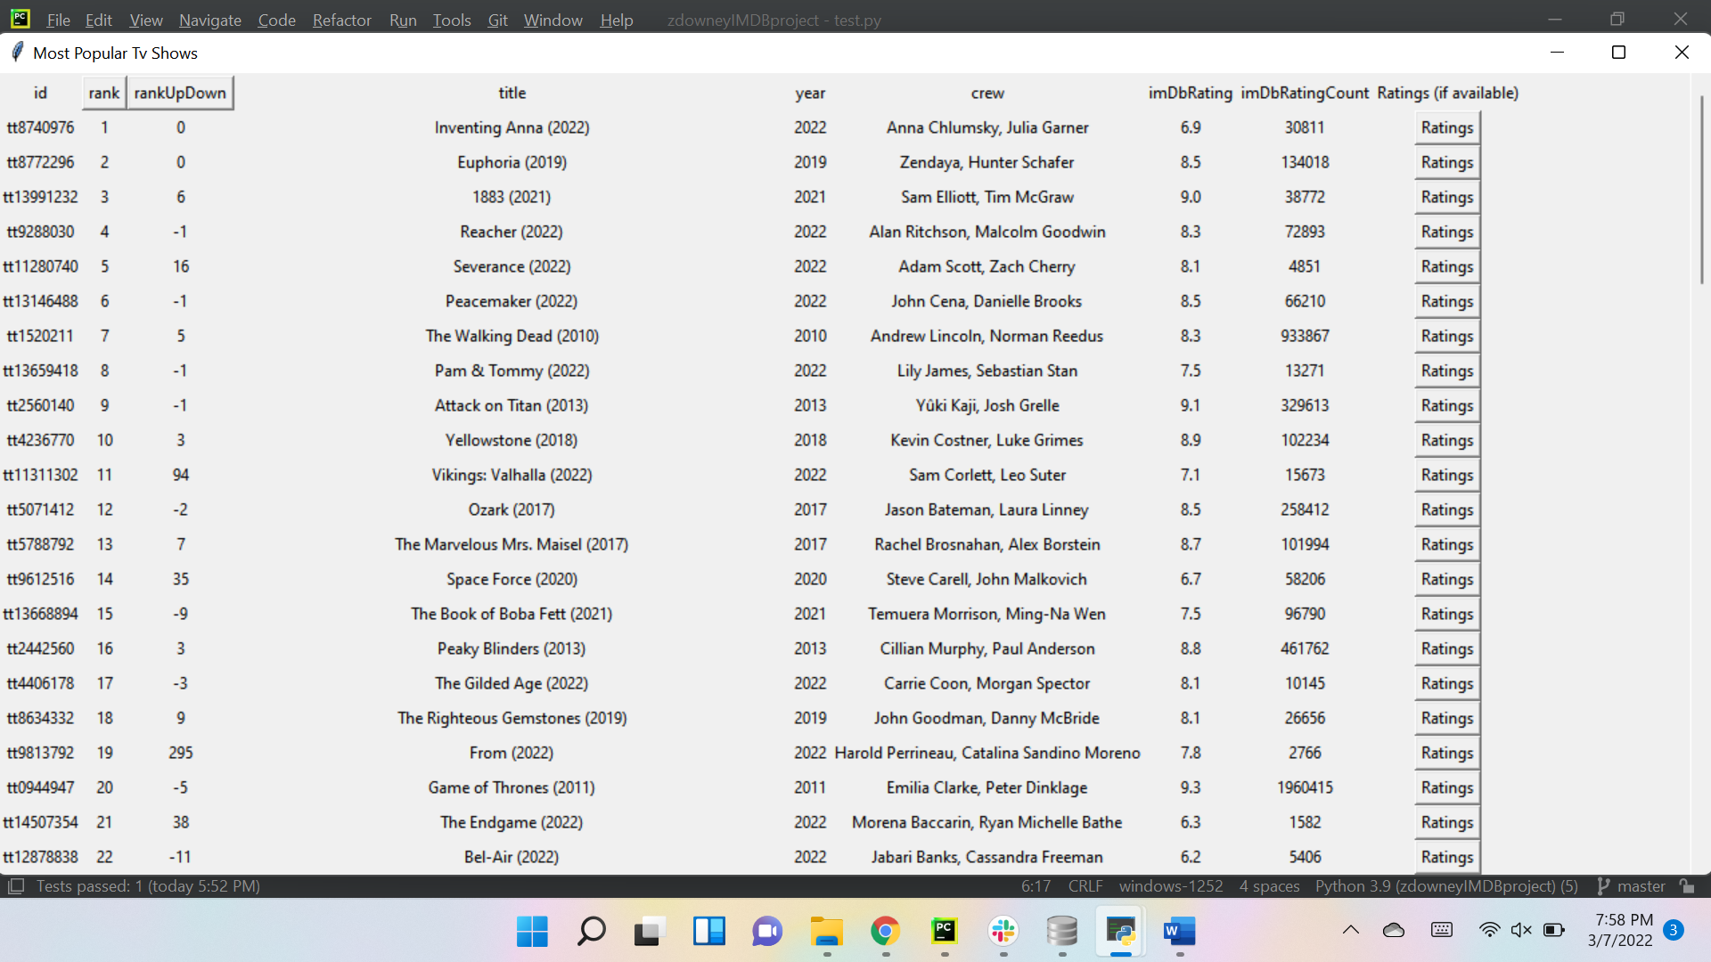

When you click the ‘rank’ button it will reverse the order of the ranks in a new window:

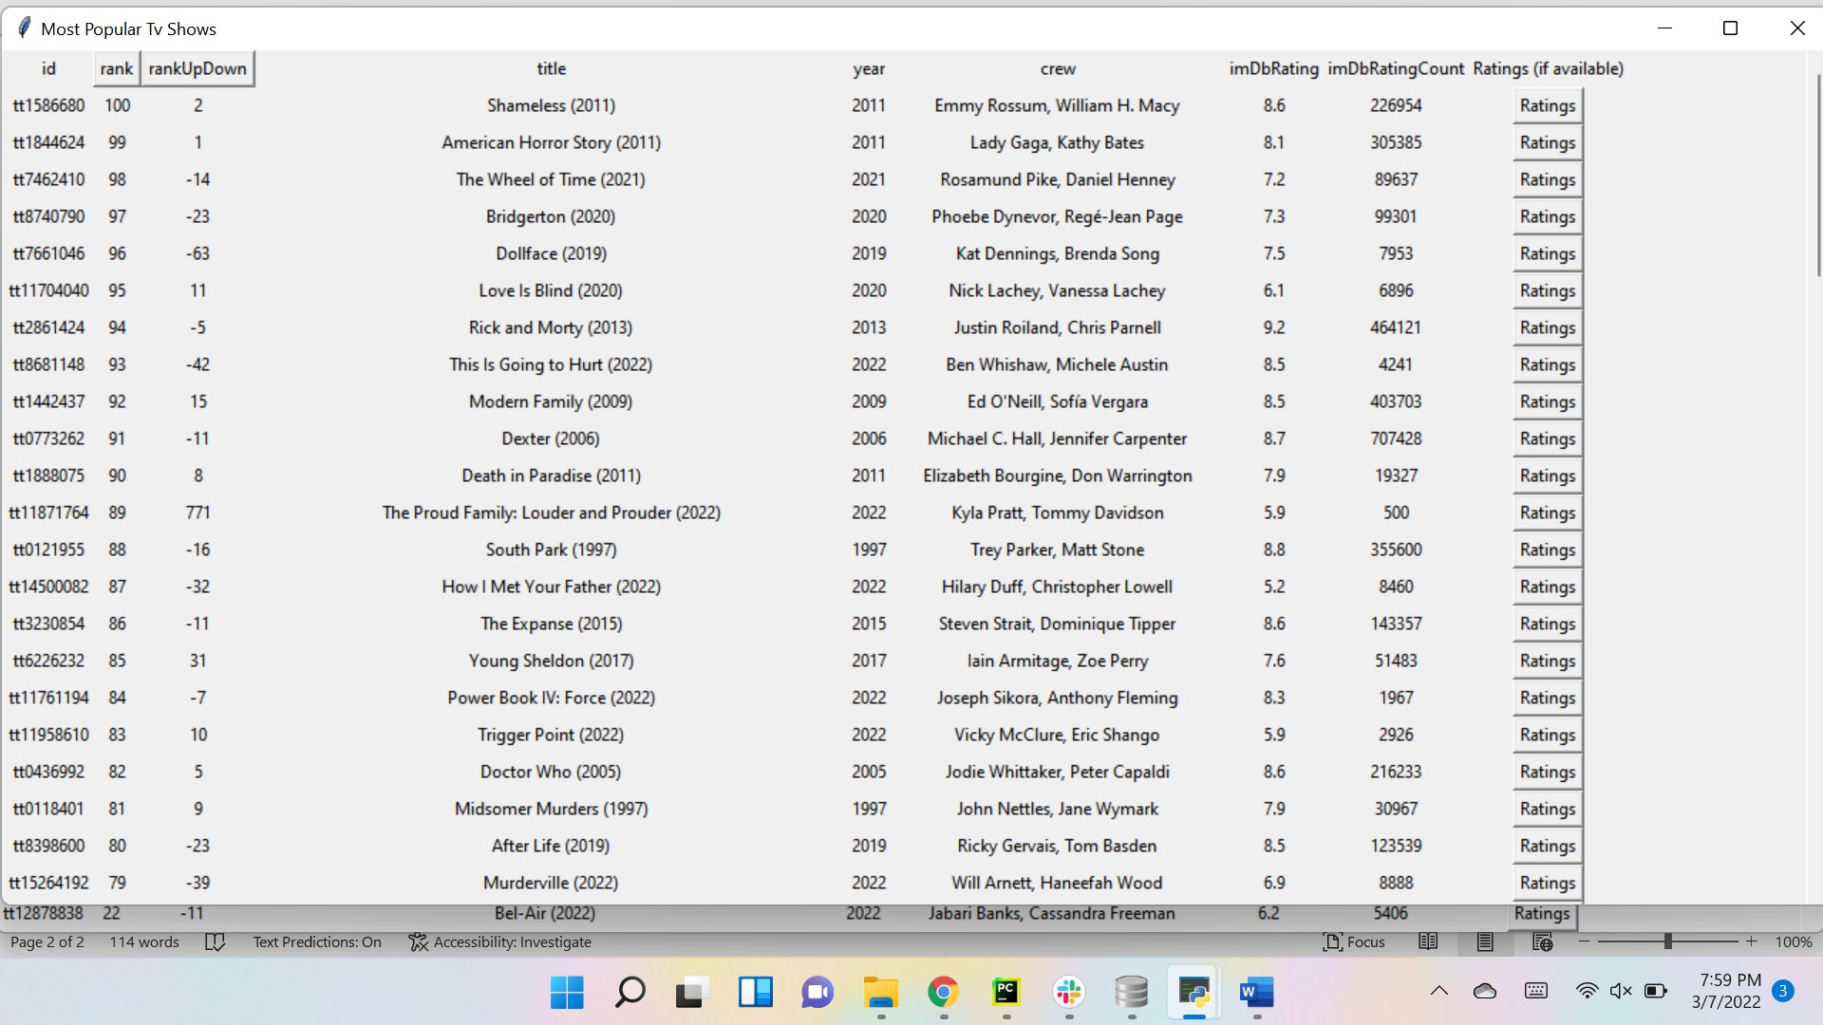

If you click the ‘rank’ button again it will return to the original rankings in a new window:

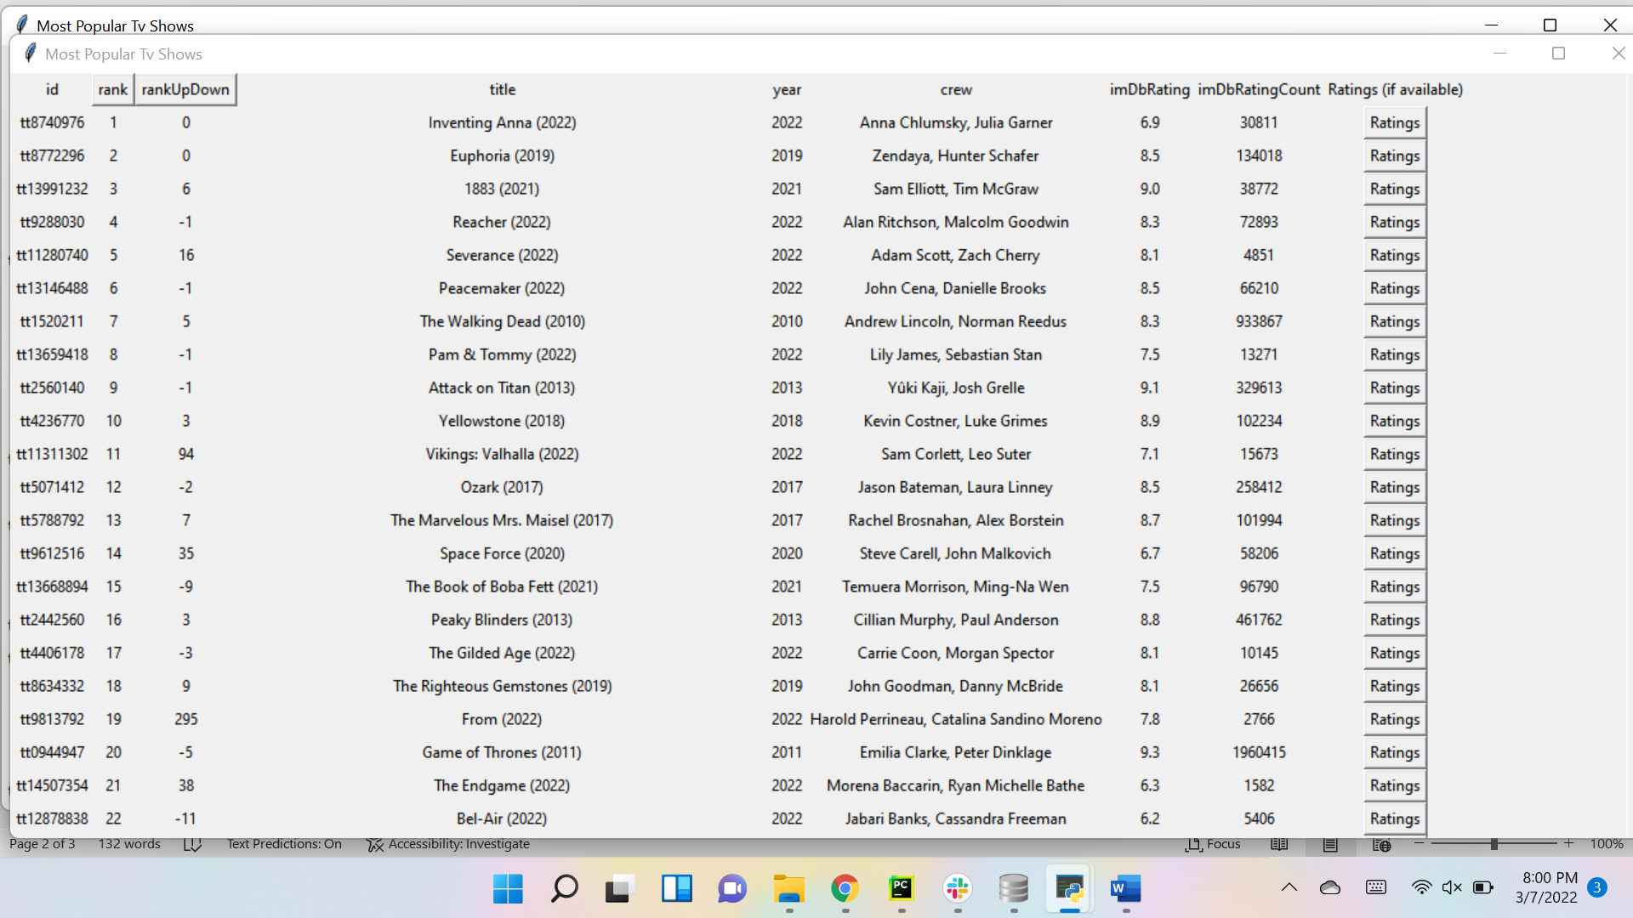

If you go back to the original table that opened when you opened ‘Most Popular Shows’ you can click the ‘rankUpDown’ button and it will sort in ascending order:

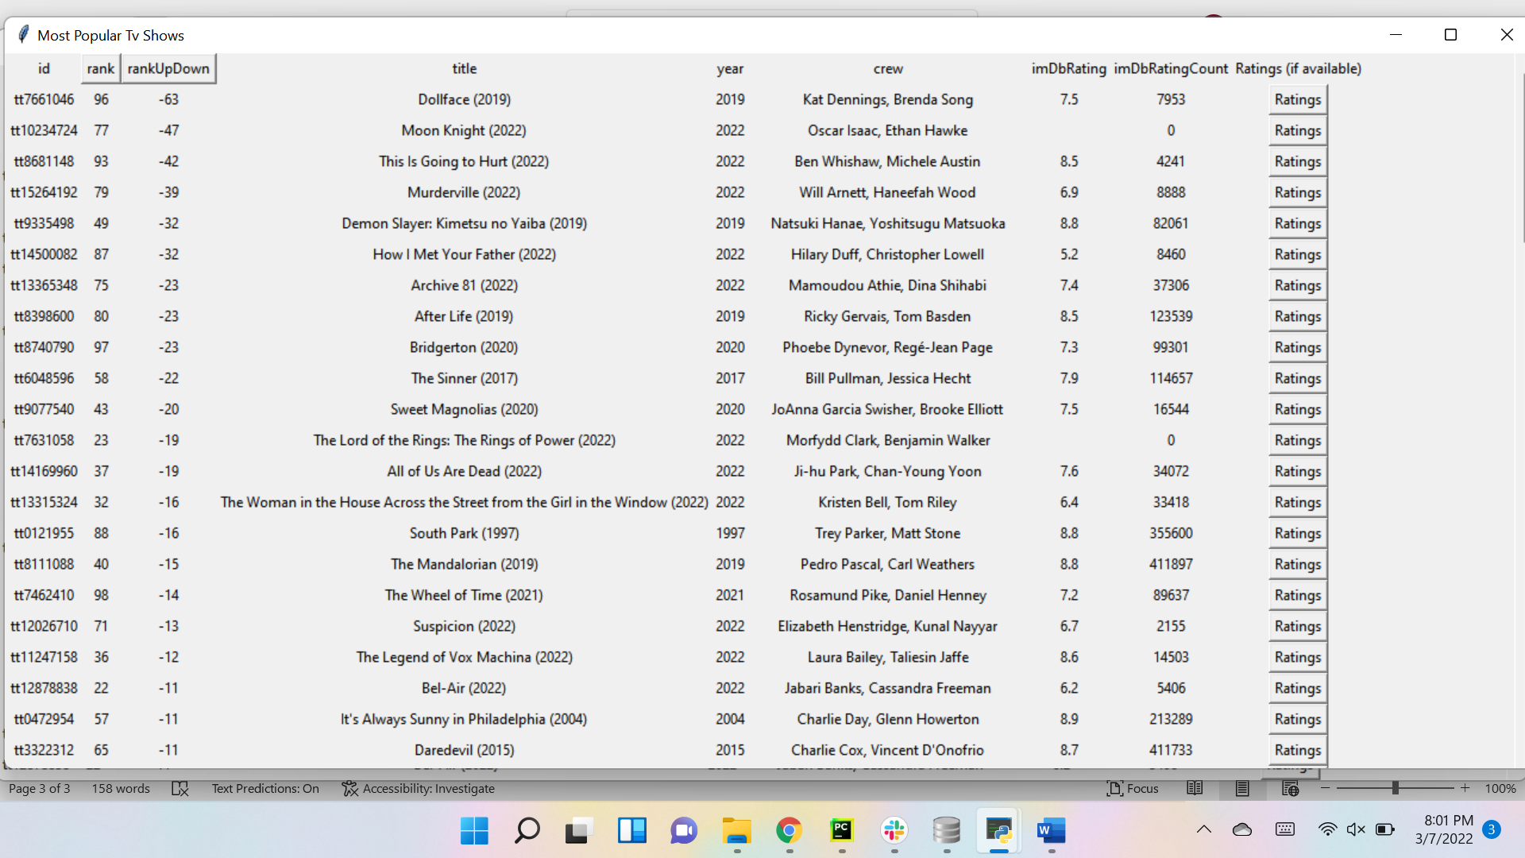

If you click the button again, it will reverse and sort in descending order:

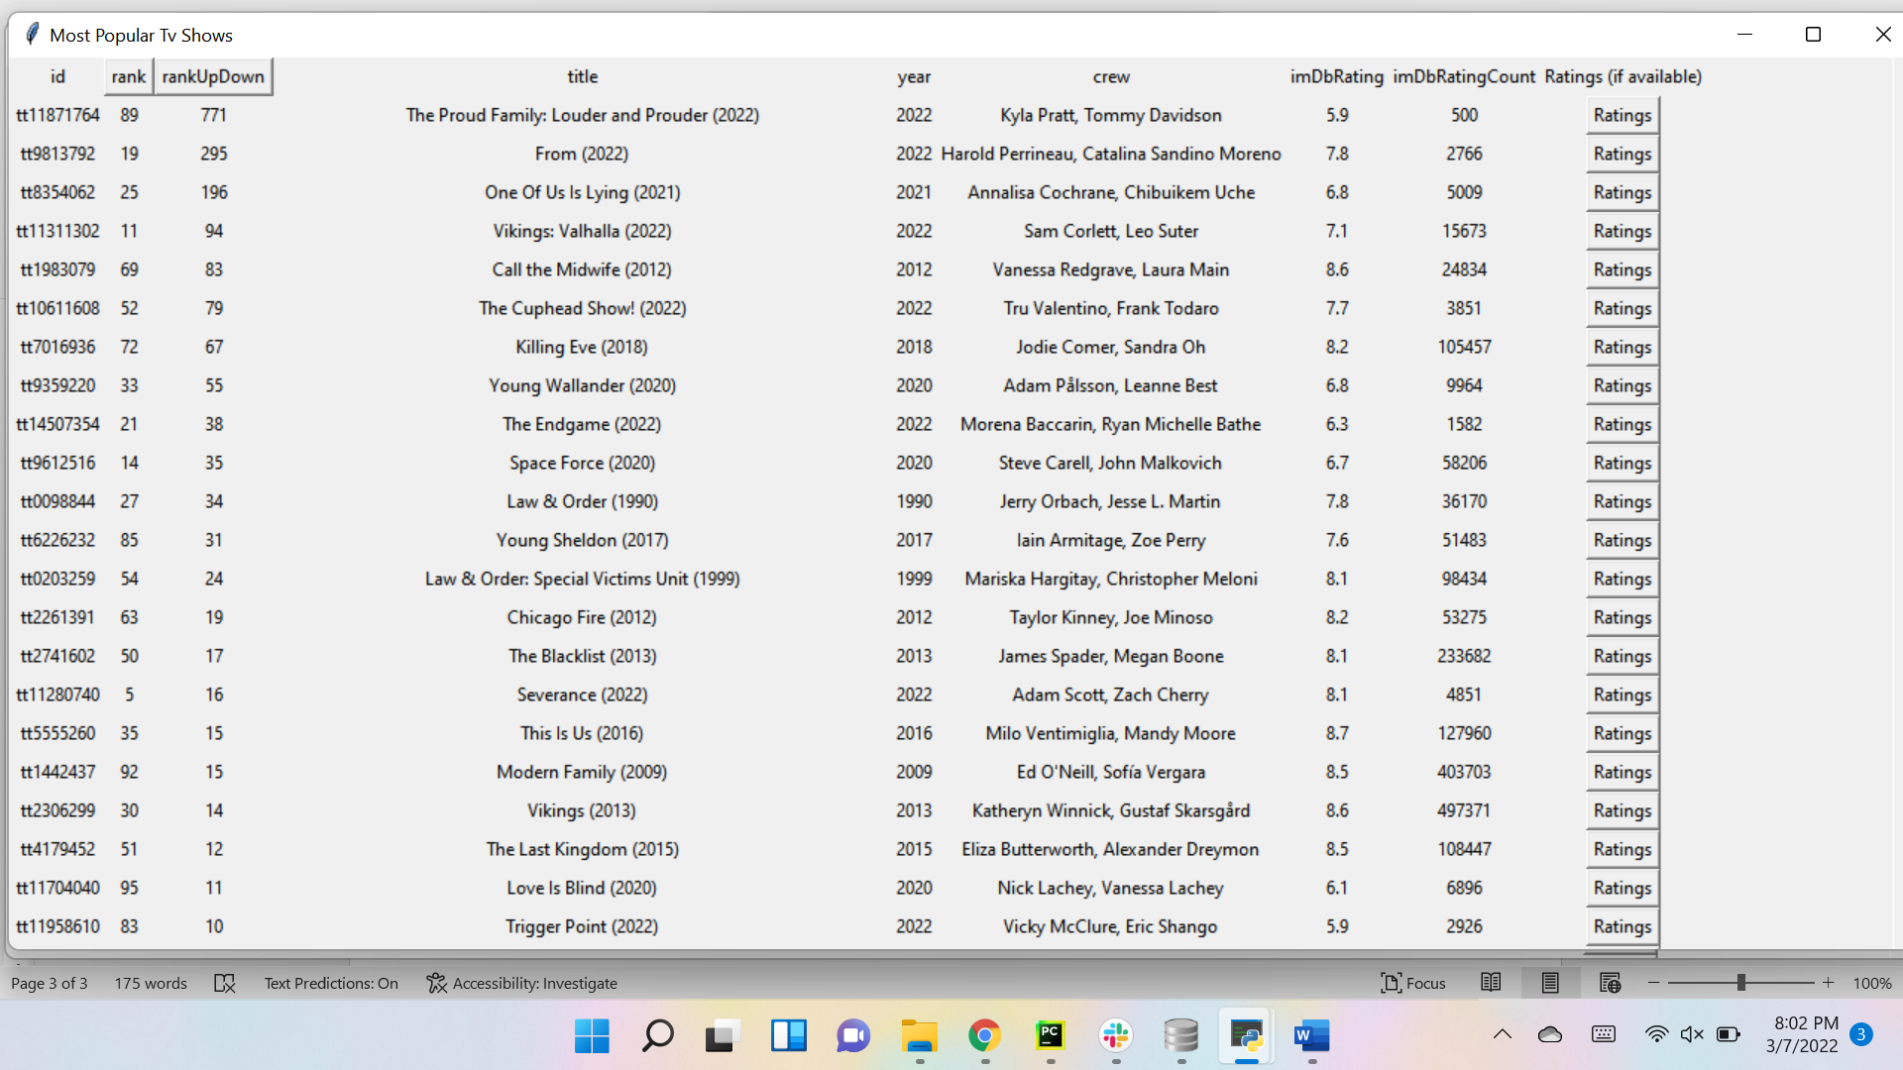

4. These same steps will occur when you use the ‘Most Popular Movies’ option, I will post the screenshots in the same order, original:

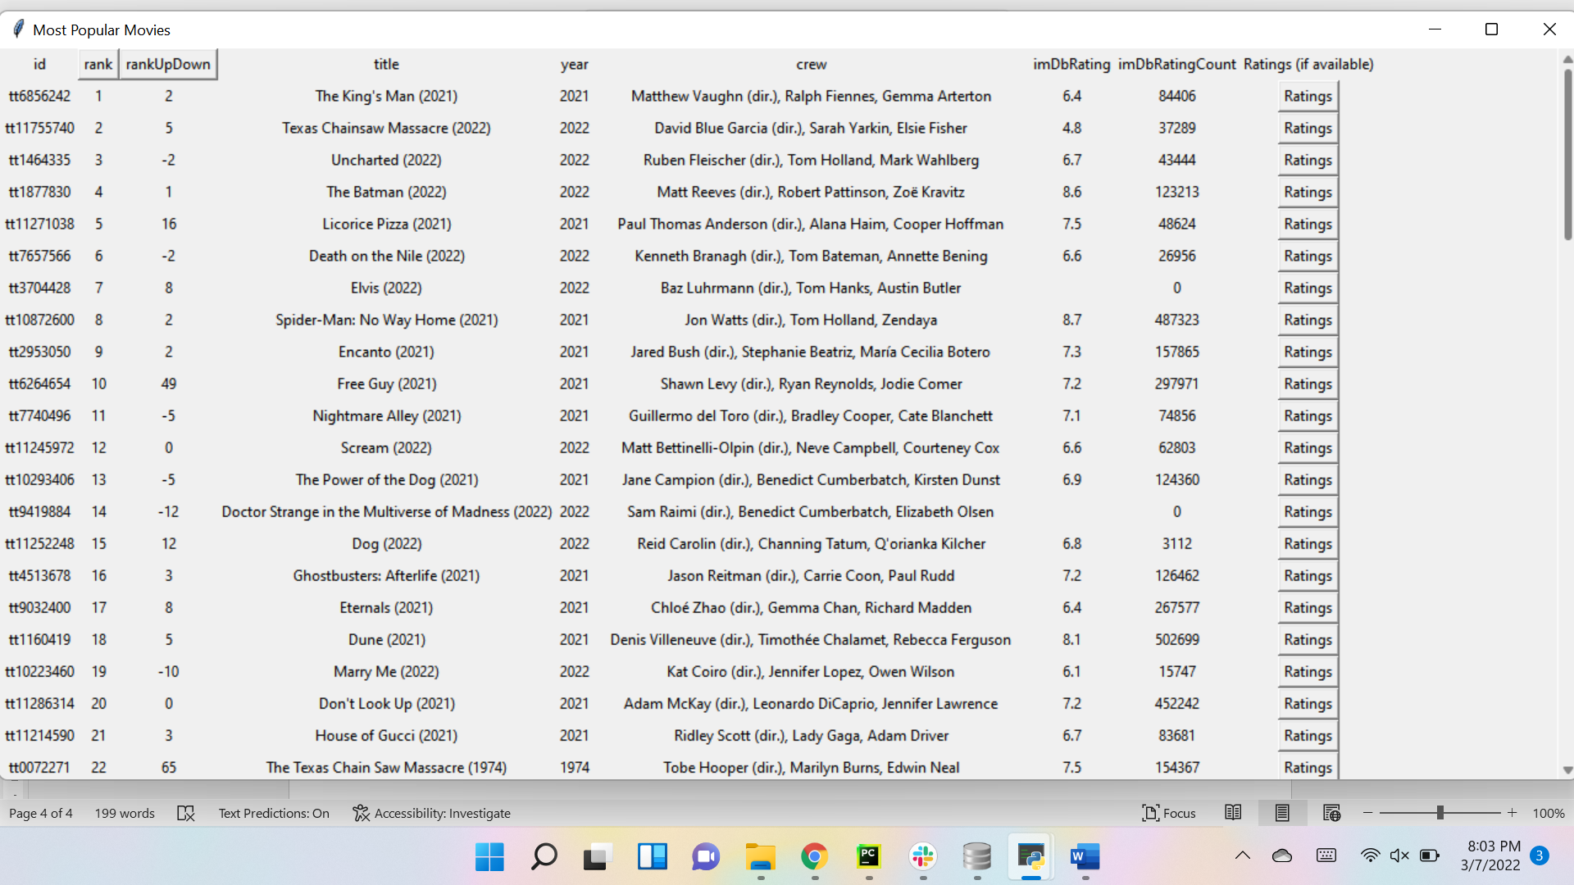

Reverse RANKED:

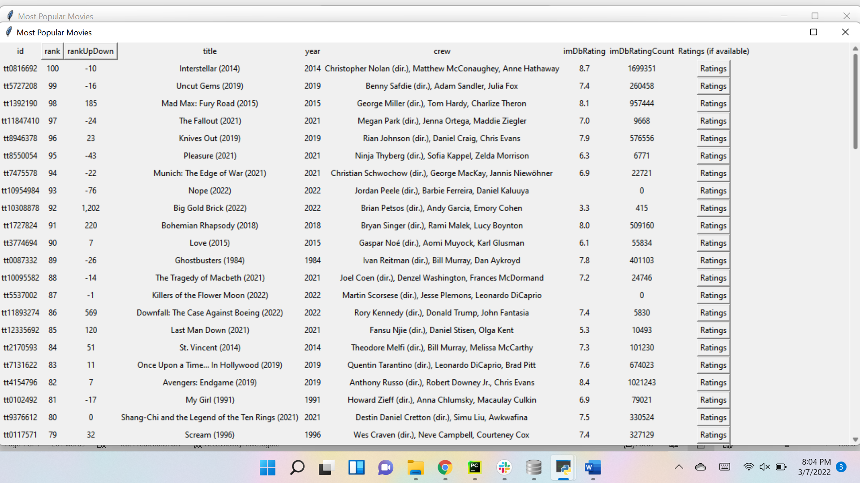

BACK TO ORIGINAL RANKS:

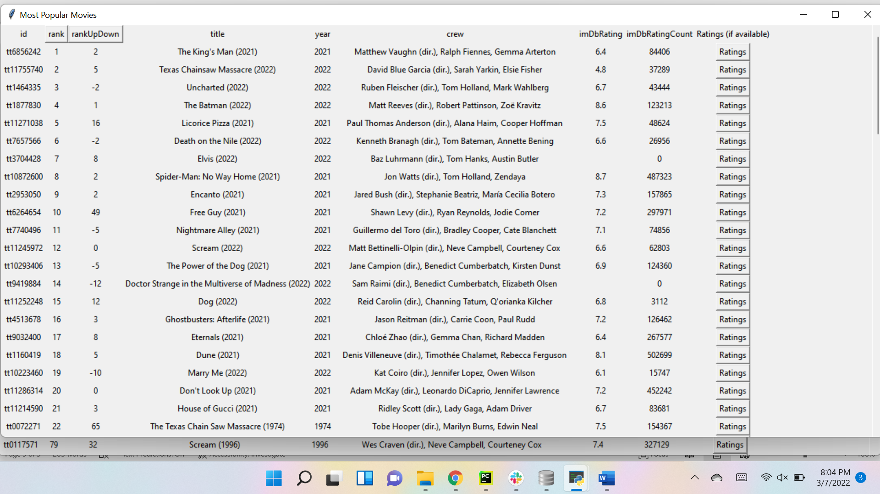

GO TO ORIGINAL ‘MOST POPULAR MOVIES’ AND CLICK RANKUPDOWN BUTTON:

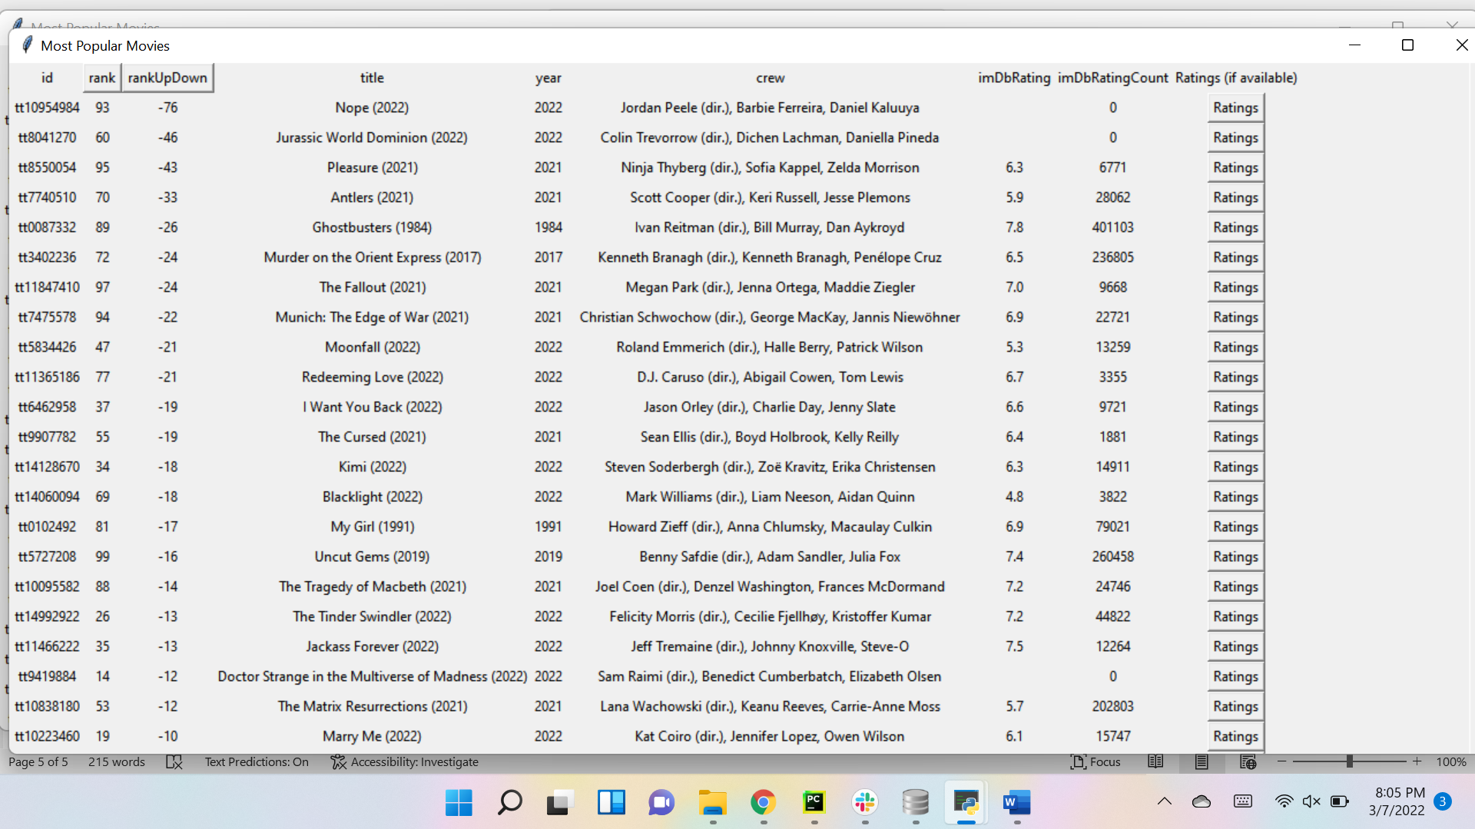

CLICK AGAIN TO REVERSE ORDER:

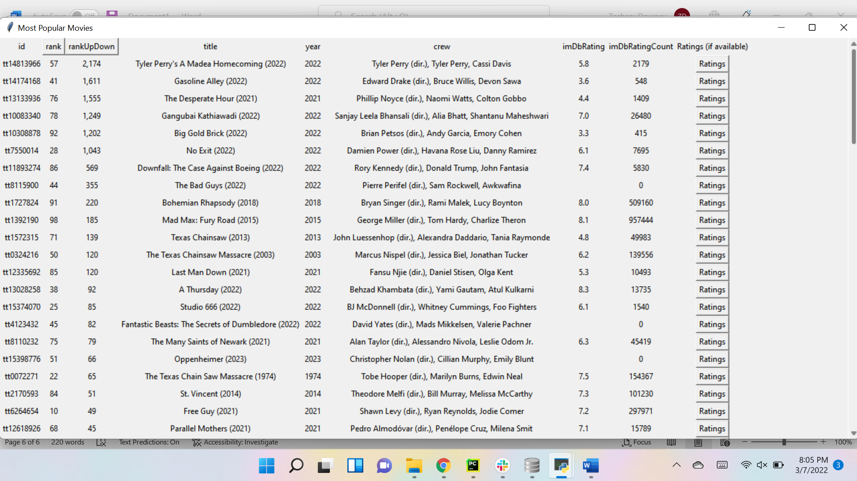

5. CLICK TOP 250 SHOWS AND GET LARGE WINDOW WITH SCROLLBAR LISTING TOP 250 SHOWS:

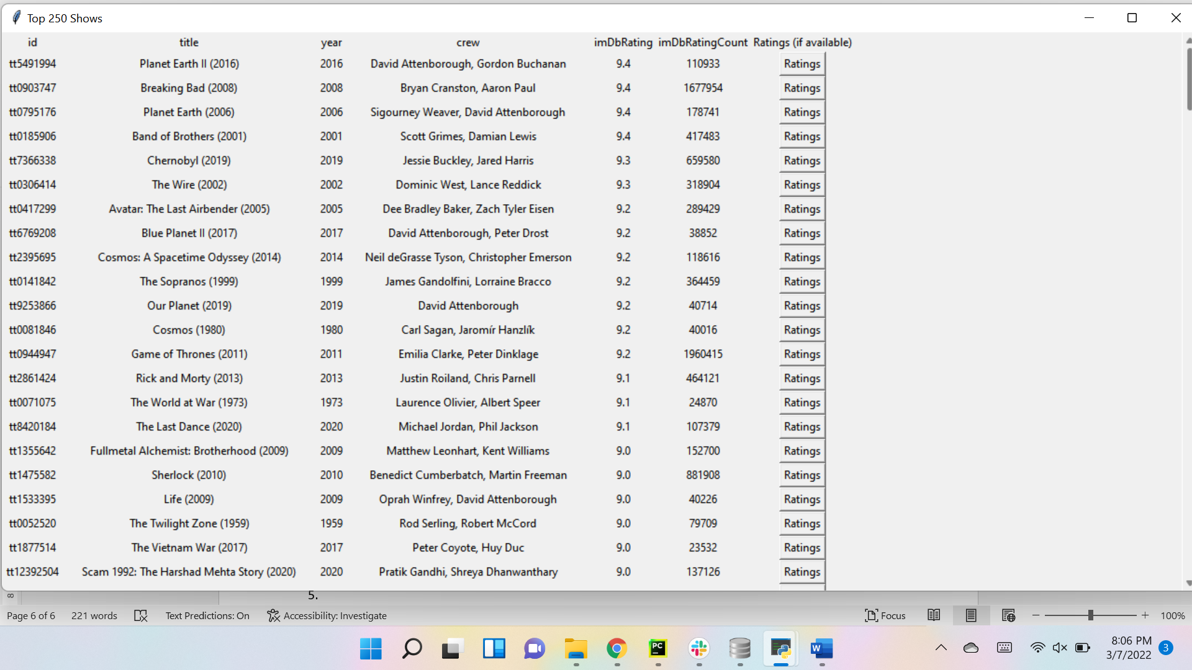

6. Same thing for Top 250 Movies:

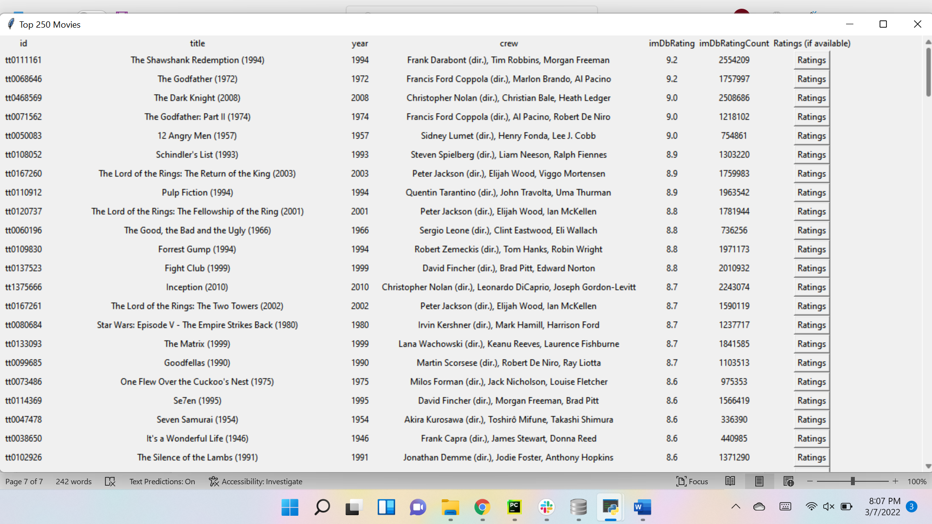

7. CLICK UP/DOWN GRAPH AND GET BAR GRAPH SHOWING NUMBER OF MOVIES/SHOWS MOVING UP/DOWN:

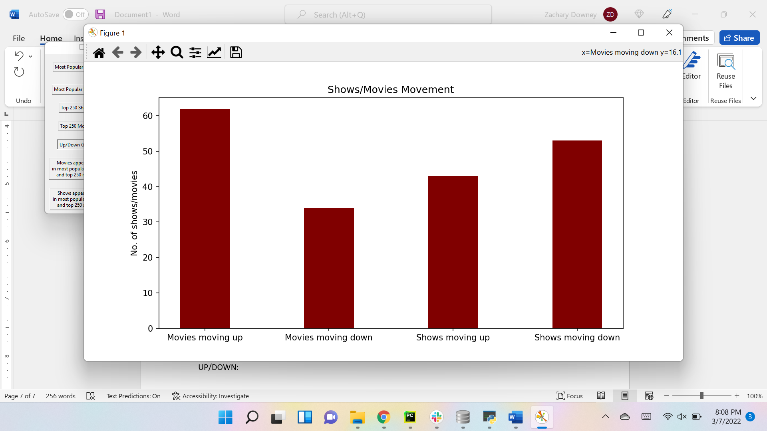

8. CLICK MOVIES APPEARING IN BOTH MOST POPULAR AND TOP 250 AND YOU WILL RECEIVE A SMALL LIST OF MOVIES THAT APPEAR IN BOTH:

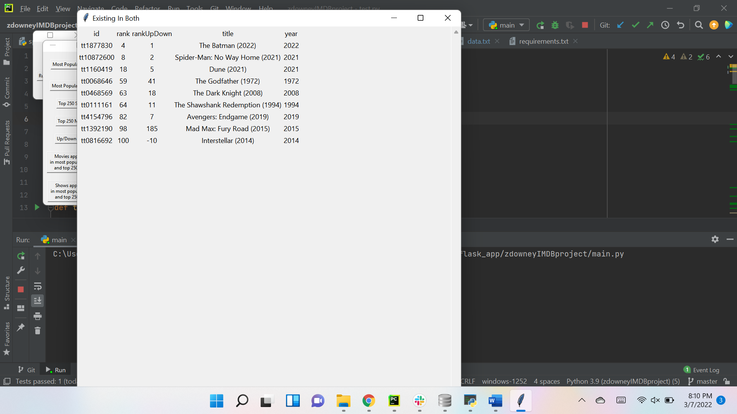

9. CLICK SHOWS APPEARING IN BOTH MOST POPULAR AND TOP 250 AND YOU WILL GET A MUCH LARGER LIST OF SHOWS THAT APPEAR IN BOTH:

